Intelligent, AI-Powered Circular Campus Resource Exchange and Asset Life Cycle Management System
- Project Problem
Universities regularly purchase computers, electronics, furniture, lab equipement, and many other usable assets. These assets are not always in use, they are also sold, stored, or even discarded.
Traditional university systems keep track of ownership, current location, and status. This system is too simple, it does not provide sufficient information about the asset or provide any methods to request or move assets around.
The proposed system will adress this issue. It will be a centrelized system where departments can register assets, move resources, request transfers, store more detailed information, and manage maintanance. The system will implement AI to improve asset management and make it more efficient.

- Project Scope
The system will a unified platform and functions for asset and resource maangment.
This includes:
- Registering Campus assets
- Publishing surplus
- Submitting and approving reseource requests
- Searching for and filtering assets
- Managing and Tracking location, ownership, maintainance, and status
- Using AI to improve speed and efficiency

- Project Objectives
The system objectives are:
- Create a centralized system for managing campus assets and resources
- Allow assests to move between departments through requests and approvals
- Improve the tracking of assets
- Reduce unnecasery expenses by reusing and maintaining resources
- Use AI to improve asset classification, searching, and matching
- Better manage maintainance and repairs
- Assumptions and Expected benefits
The system assumes each department will provide accurate information about their assets and regularly update them. It also assumes that only authorized users will have access to the system and that a sufficient database will be available for the AI functions.
The expected benefits are reducing unnecessary spending from purchases to maintainance, increase the reuse of available resources, improve asset tracking, and making the transfer of assets between departments easier and more efficient.

5. Stakeholders

The primary stakeholders of the system are:
- Representatives from departments
- Custodians of assets
- Requesters
- Administrators
- Procurement officers
- Finance officers
- Maintenance officers
- Sustainability officers
- System administrators
Every stakeholder would have interaction with the system in a manner that corresponds to their specific role.

6. Stakeholder Roles and Permissions

Stakeholders have access to various system functionalities.

- Representatives from departments are allowed to register assets and resources of their department.
- Custodians of assets are allowed to follow up on the condition, status, and ownership of the assets.
- Requesters are allowed to search for assets and submit requests.
- Administrators are allowed to approve requests and transfers.
- Procurement and finance officers can view information about purchasing, cost, and savings.
- Maintenance officers can follow up on the inspections, maintenance, and repairs.
- Sustainability officers can track reuse, recycling, and sustainability information.
- System administrators can follow up on user management and permission management in the system.

7. Current Process

Now departments can have excess assets while other departments buy those same resources. The current process for managing assets basically revolves around collecting data such as the owner, location, and condition.
The system will add value to this process in such a way that assets with surplus can be posted. Other departments can make a search of such assets and place a request. After the request has been reviewed and approved, the asset can be transferred. Maintenance, repair, donation, recycle and disposal will be managed in order to be able to follow up the whole life cycle of the asset.

8. Criteria for Project Success
The project will be successful if the system will be able to register and track assets, facilitate searches and requests, manage the approvals and transfer processes, and collect and store asset information. The functions of the artificial intelligence will provide useful classification and matching of available resources and requests. The system will help in increasing reuse and decreasing the purchases as well as providing financial and sustainability benefits.

9. Preliminary Project Plan
The project will follow the official COSC 336 Fall 2026 schedule, beginning with planning and requirements and ending with the final implementation, testing, and presentation.
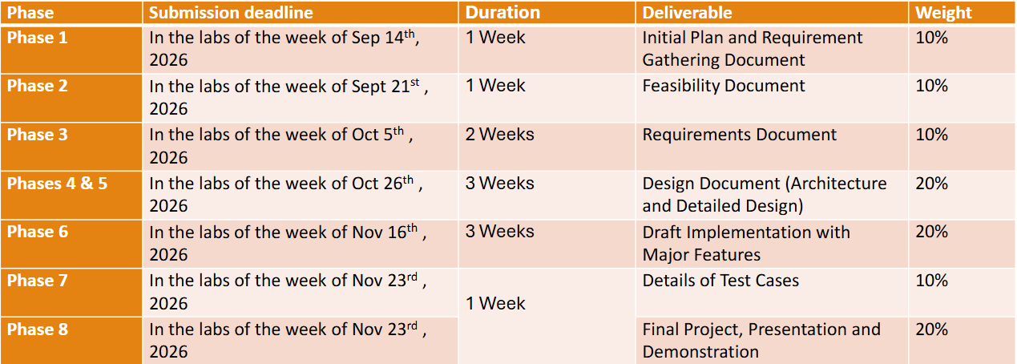
- Task Assignments
The project will be finished by a team of two people. The work will be split between the two people based on what's needed and how much work there is in each part of the project. Jobs will be given at the start of every part to make sure the work is even and let both people help with parts of the project. Both people will work together on tasks, like planning, designing, building, testing writing documents and the final show.

- Dependencies
Each phase depends on the previous phase being completed:
Planning → Feasibility → Requirements → Design → Development → Testing → Final Submission
For example development cannot start properly until the requirements and system design have been set.

- Risks
The main project risks are time delays on tasks, problems with AI, trouble when joining system parts and scope that grows too big. These risks can be cut by focusing on must‑have features, duties, early start on hard tasks testing all the time and frequent project check.

- Resource Allocation
The main resources, for this project are the team members, personal and university computers, development tools, Git and GitHub a database system, UML and design tools, testing tools and suitable AI libraries or services. These resources are shared according to each team members duties. Used during the design, development, testing and documentation stages.

